Peter Julius M. Estacio
Grouped with:
Augusto Gabbriel M. Calilung
Rafael Luis Mari R. Lambo
ENGG 27.01 - M
January 29, 2026

Progress Report 1 for Project 1: Fixed-Point Approach for Finding Roots of Polynomials

As of January 29, 2026, initial progress has been made with Augusto Gabbriel M. Calilung and Rafael Luis Mari R. Lambo as groupmates. Specifically, a C++ program has been developed to read a polynomial file, process the coefficients, utilize the fixed-point approach for all non-constant coefficients, and to determine whether the result is diverging or converging based on the iterations.
For file processing, a polynomial file called test was made using the basic example polynomial provided. The file is parsed and validated for the “POLYNOMIAL” token along with the degree of the polynomial, stored as a string and integer respectively. Using this stored integer, the program initializes an array of appropriate size and stores the coefficients indexed by their degree.
The user then is able to input a initial estimate g(0). To implement the fixed-point approach, each non-constant term of the polynomial equation was isolated to form the function g(x) = x. Specifically, for any given non-constant term ax^{n}, the term would be transposed then the whole polynomial equation would be divided by ax^{(n-1)}, thus isolating x and representing g(x) as a rational function. For each iteration of g(x) then, the program attempts to use the fixed-point method to derive a root of f(x).
Determining convergence or divergence was also initially implemented. Specifically, once the difference between the current iteration and the previous iteration equal 0, the program assumes convergence. The program then displays the result at maximum precision available for a double. On the other hand, the program assumes divergence should the results equal NaN, inf, or -inf. Currently, the fixed-point method is limited to 100 iterations should the problem face problems detecting convergence and divergence.
Further progress includes but is not limited to more robust convergence/divergence detection (especially in the case of oscillating results), header implementation, flexible polynomial file validation, and stricter user input validation. Screenshots of the initial results are shown below.

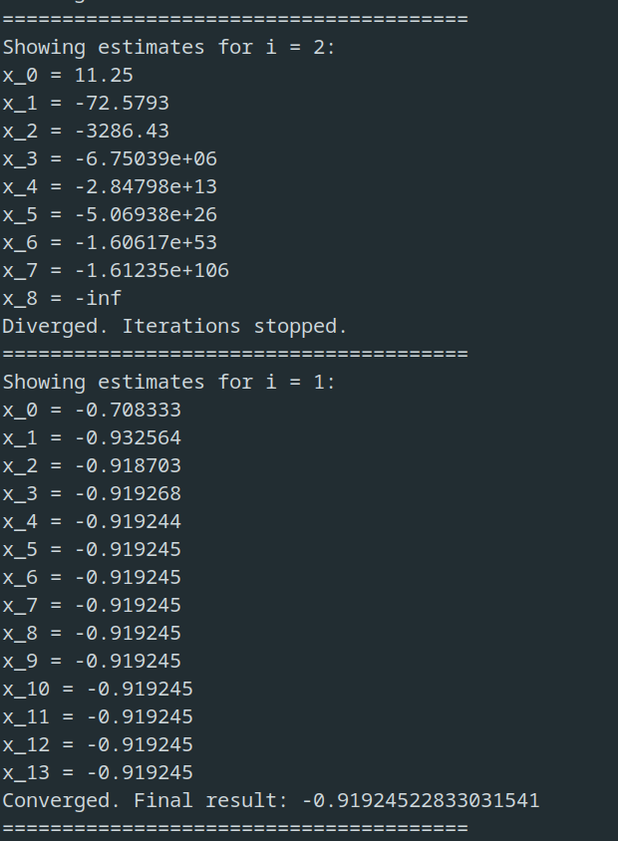
` 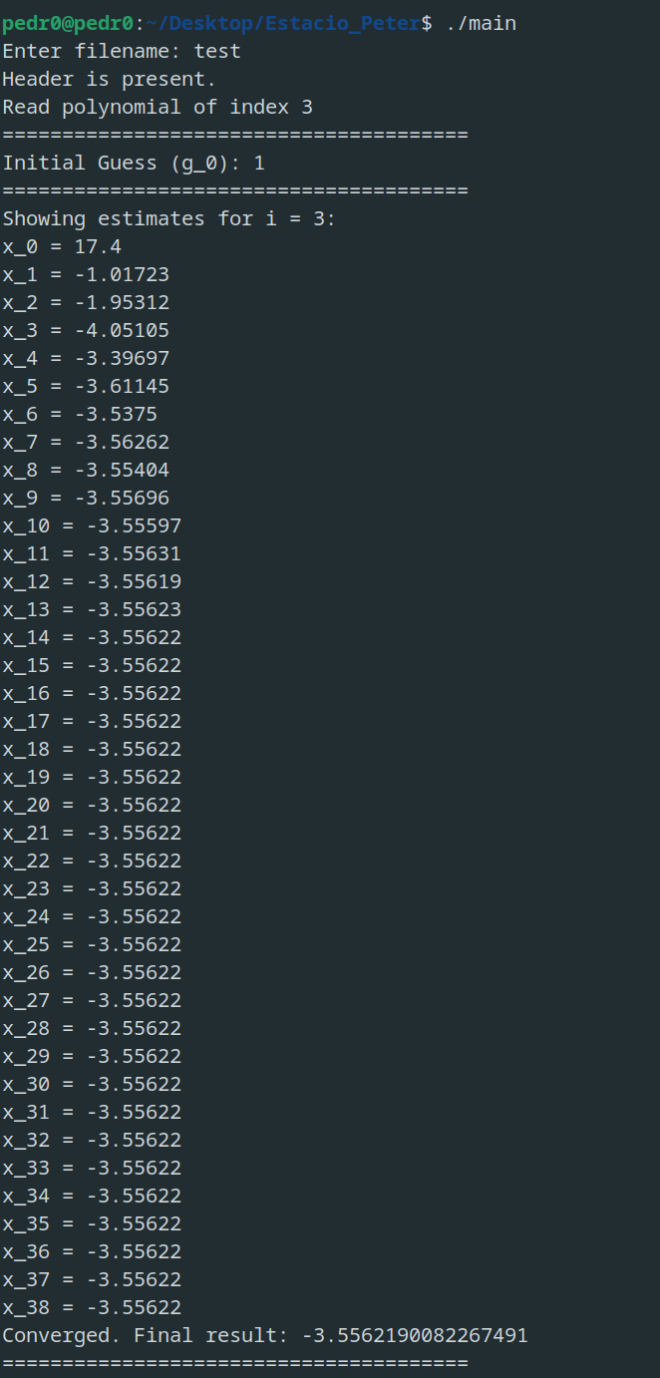
sample screenshots – program executable run and example results
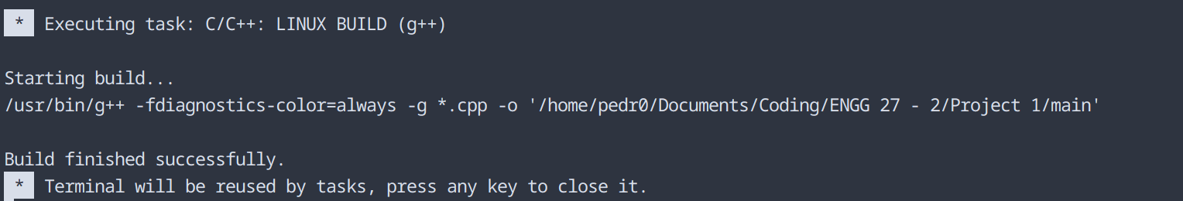
sample screenshot – compilation on Visual Studio Code
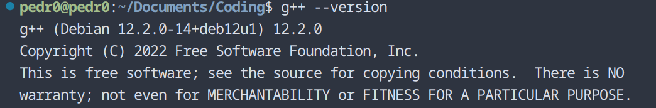
compiler version – g++ (Debian 12.2.0-14+deb12u1) 12.2.0
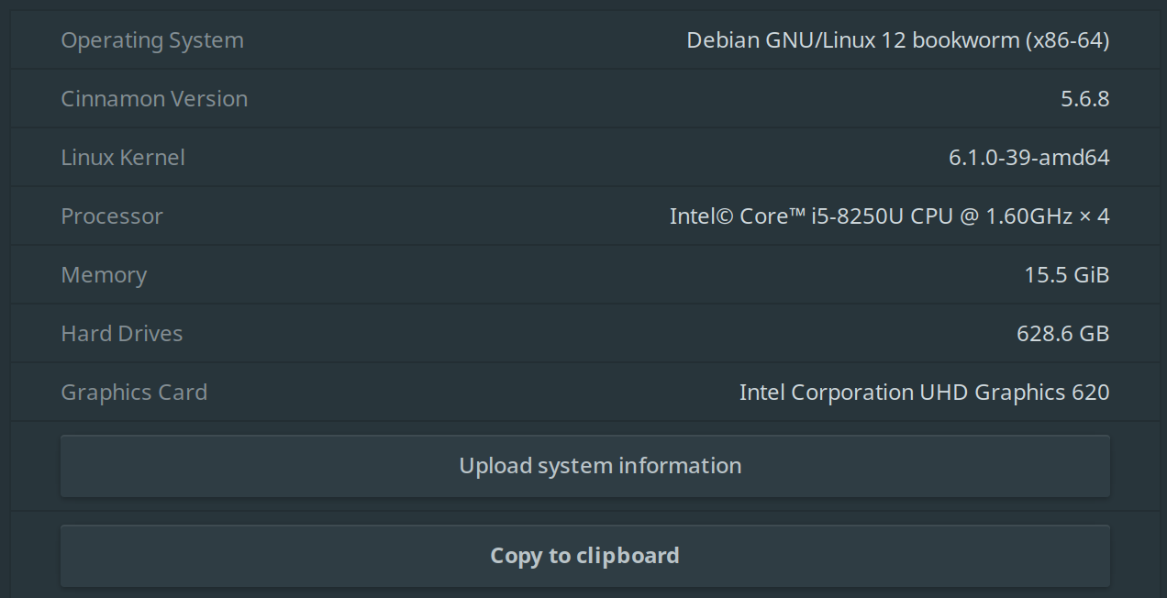
operating system – Debian 12 bookworm, Cinnamon version 5.6.8
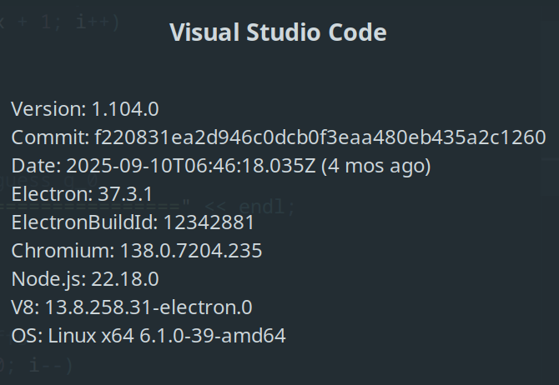
IDE – Visual Studio Code ver 1.104.0

